
Dashboard Design

Team ID | MCA
Project Name | Online Learning Engagement and Student Performance Analysis
Maximum Marks | 5 Marks
Online learning platforms generate large amounts of data related to student engagement, participation, learning activities, and academic performance. However, analyzing this data in raw form can make it difficult to identify important patterns, trends, and factors that influence student performance.
The Online Learning Engagement and Student Performance Analysis project aims to develop an interactive and visually appealing dashboard that transforms raw student data into meaningful visual insights. The dashboard will help users analyze student engagement and performance using appropriate charts, KPI cards, filters, slicers, drill-downs, and other interactive features.

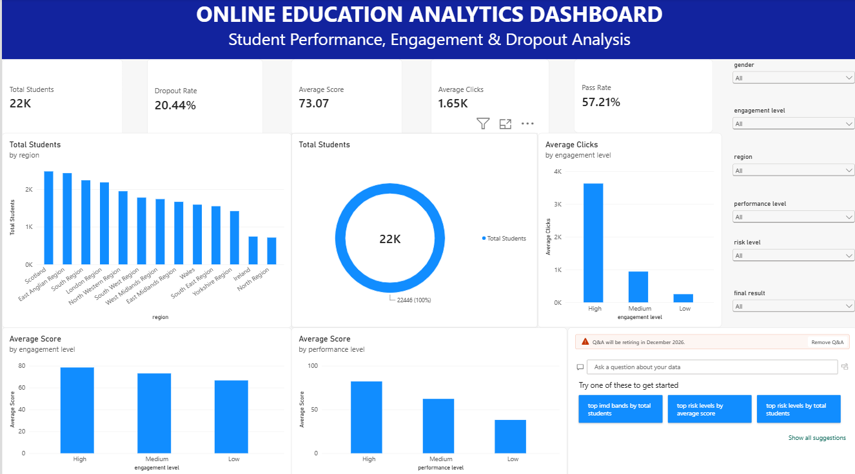
Sample:
Here are five potential outcomes from the dashboard image provided:
- Total Distance Traveled: The service has covered a total distance of 4.57K kilometers, indicating the extent of operations.
- Revenue Generation: The dashboard shows a revenue of 9.94 million INR, reflecting the financial performance of the service.
- Passenger Count: The total number of passengers recorded is 423, providing insights into user engagement and service utilization.
- Yearly Passenger Trends: The bar chart indicates the passenger count for each year, highlighting that 2021 had the highest count (104 passengers), while 2022 shows a decrease to 47 passengers.
- Daily Passenger Distribution: The pie chart reveals passenger distribution by day, helping to identify peak days for the service and inform operational adjustments.
The major objectives of the project are:
- To collect and analyze online learning engagement and student performance data.
- To transform raw data into meaningful and understandable visualizations.
- To develop an interactive dashboard using Microsoft Power BI.
- To use appropriate charts, KPI cards, slicers, filters, and interactive elements.
- To identify patterns and trends in student engagement and academic performance.
- To analyze factors that may be associated with higher or lower student performance.
- To provide users with clear insights that support data-driven educational decision-making.

